**Database searching – Scopus**

The search process:

* Identify your key concepts
* For each key concept think of alternatives (e.g. synonyms, broader, narrower terms)
* Construct search strategy
* Run search and see if results are relevant
* Adapt search strategy to optimise results
* Save results (to reference management software?)

**1 – Searching**

**Recommended:** Add search fields so there is one box for each key concept

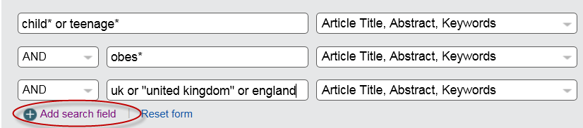

Common functions/operators:

|  |  |
| --- | --- |
| **Function/Operator** | **Example** |
| none | e.g. finite element – finds items containing both the words finite and element (includes singular/plural, us/uk spelling variations) (assumes AND operator between words) |
| **AND** operator | e.g. finite AND element – finds items containing both the words finite and element (includes singular/plural, us/uk spelling variations) |
| **OR** operator | e.g. recycling OR recovery - finds items containing any of the following: the word recycling, the word recovery or both words (includes singular/plural, us/uk spelling variations) |
| W/n (n is number) proximity operator | e.g. finite W/5 element – finds items where there are up to 5 words between the words finite and element (any order) |
| * truncation character | e.g. load* - finds items containing any word beginning with load (load, loading, loaded etc) |
| “ phrase searching | e.g. “finite element” finds the phrases: finite element, finite elements, finite-element etc. This can narrow down search |
| Limit by title | Select Article Title from drop down menu next to search box. This can narrow down search |
| Refine panel | Left hand side. Can be used to narrow down search |
| Search history | Displays at bottom of screen when in search mode (click on Search tab below Scopus name) |
| Edit or save a search, create an alert for a search | See icons at top of results list or in search history |

**2 – Looking at results/altering search strategy**

* **Sort results –** you can change the order in which the results are displayed if you wish – see above results list (right hand side) e.g. sort by most “relevant” or most recently published
* **Scan through some titles**– helps you determine if your search strategy is effective/needs altering (i.e. are you finding a high percentage of possibly relevant or irrelevant items?)
* **Read abstracts** - click on item title. Use the abstract (summary) to help decide whether a paper is worth reading –search terms used are in bold. You may also identify more search terms you may wish to use
* **Alter search strategy** you may need to revise your search strategy (too many/too few results, need to widen/narrow search)
* **Access full text** **(journal articles)** – click on the **SFX** link (tries to get you to the full text if we have a subscription)
* **Select useful records** – tick box at side of record. These can be saved for later use e.g. details can be exported to Refworks

**3 – Saving searches or results/Creating alerts**

Once you register for a personal account you will be able to do the following:

* **Save searches** - you can then come back at a later date and rerun your saved search (Save link/icon above results list)
* **Save selected results** – you can then build a list of references over several search sessions. Select records and click on More link above the results to add to My Lists; you can then go to My Lists to save permanently
* **Create alerts** – you can receive regular emails telling you about new items added to the database matching your search strategy (Set Alert link/icon above results list)

To register:

* Click on login link (top right hand corner)
* Click on Other Institution Login – now log in via Shibboleth (Institutional login) using your University username and password
* Click on the Activate Link now appearing in top right hand corner (your name will now appear there)
* To use personal features you will need to login whether on site or off site

**4 – Exporting reference details to reference management software (e.g. Refworks)**

* Select items by ticking boxes at side of records
* Click on the Export icon at top of results list, select the format e.g Refworks direct export